Week 34
English I
April 10-14
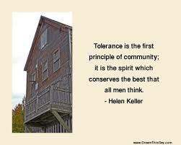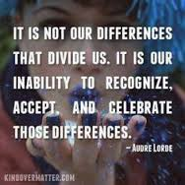
LG: Determine a theme or central idea of a text and analyze in detail its development over the course of the text, including how it emerges and is shaped and refined by specific details; provide an objective summary of the text.
LG: I can read closely and find answers explicitly in text and answers that require an inference
LG: I can thoroughly support both explicit and inferential questions by analyzing an author’s words and determining multiple pieces of textual evidence that strongly support those questions.
LG: I can analyze how an author uses rhetoric to advance his/her point of view.
LG: I can demonstrate the understanding of figurative language, word relationships, and nuances in word meanings.
M: Weekly Letter
Did you attend the musical? Please turn in program for bonus pts.
AIR Test Practice (ELA Section)---report to designated testing sites
Distribute new study guide for chapters 6-15
HMWK: read chapter 6-—complete accompanying SG

T: Did you attend the musical? Please turn in program for bonus pts.
Read Chapters 8-9 aloud
HMWK: read chapters 7-8— complete accompanying SG

W: Analyzing quotes & making poster: How does narrative writing lead to argument?
HMWK: read chapters 9-10--- complete SG & I will be collecting the SG on Thursday

TH: Collect Study Guide
Reading Quiz: Chapters 1-10 (multiple choice and short answer)
How do narrative elements create argument?
HMWK: read chapters 11-12 (by Monday)-------reading for argument and narrative & 2 vocab words or a strong line of writing.

F: No School -----in recognition of Good Friday

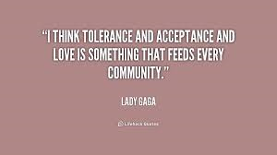

QUARTER FOUR: How do you contribute to society while maintaining your convictions?
- I can read closely and find answers explicitly in text and answers that require an inference
- I can thoroughly support both explicit and inferential questions by analyzing an author’s words and determining multiple pieces of textual evidence that strongly support those questions.
- I can determine how specific details in the text reveal and continually refine a theme.
- I can analyze how complex characters develop over the course of the grade-appropriate text, interact with other characters, and advance the plot of a text or develop the theme.
- I can analyze how specific word choices build upon one another to create a cumulative impact on the overall meaning and tone of a text (i.e., denotative, connotative, figurative)
- I can analyze how an author uses rhetoric to advance his/her point of view.
- I can analyze the impact of a particular subject or key scene from another artistic medium.
- I can analyze (and critique) how an author draws on and transforms source material in a specific grade-appropriate work
- I can integrate interesting and appropriate digital media in a strategic manner to improve my presentation.
- I can determine or clarify the meaning of unknown and multiple-meaning words and phrases based on context clues, changes in word patterns, consulting reference materials, and verifying preliminary determination of the meaning.
- I can demonstrate the understanding of figurative language, word relationships, and nuances in word meanings.
- I can effectively use my knowledge of the structure and context of language to acquire, clarify, and appropriately use vocabulary.
- I can follow the rules for collegial discussion.
- I can come to discussions prepared, having read and researched material under study; explicitly draw on that preparation by referring to evidence from texts and other research on the topic or issue to stimulate a thoughtful, well-reasoned exchange of ideas.
- I can propel conversations by posing and responding to questions that relate the current discussion to broader themes or larger ideas; actively incorporate others into the discussion; clarify, verify, or challenge ideas and conclusions.
- I can respond thoughtfully to diverse perspectives, summarize points of agreement and disagreement, and, when warranted, qualify or justify their own views and understanding and make new connections in light of the evidence and reasoning presented. (—Socratic Seminar as summative assignment)

